 

INSTITUTE FOR ADVANCED

COMPUTING AND

SOFTWARE DEVELOPMENT

AKURDI, PUNE

Documentation On

**“ANDROID IN APP ADVERTISING”**

PG-DAC MAY 2021

*Submitted By:*

**Group No: 81**

**MEGHA CHETAN CHINCHAMALATPURE**

**ROLL NO :- 1114**

**MAYURI MADHUKAR JADHAV**

**ROLL NO :-1113**

**Mr.Prashant Karhale**

**Centre Coordinator Project Guide**

**Table of Contents**

**1. Introduction..................................................................................................................... 4** Document Purpose....................................................................................................... 5 Problem Statement....................................................................................................... 5 Product Scope.............................................................................................................. 6 Aim & Objectives............................................................................................................ 6

**2. Overall Description ......................................................................................................... 7** Product Perspective...................................................................................................... 7 Benefits of Society Management System ..................................................................... 7 Operating Environment................................................................................................ 8 Design and Implementation Constraints.......................................................................... 8

**3. Requirements Specification ............................................................................................ 8** External Interface Requirements........................................................................................8

**4.**  **System Diagram ............................................................................................................ 9** Activity Diagram ......................................................................................................... 9

Data Flow Diagram.................................................................................................... 10

Class Diagram ........................................................................................................... 11

Use Case Diagram ..................................................................................................... 12

5. **Conclusion ..................................................................................................................... 13** Future Scope.............................................................................................................. 14

**6. References...................................................................................................................... 14**

**List of Figures**

Figure 1 Application Activity Diagram ............................................................................. 11 Figure 2 User Activity Diagram.......................................................................................... 12 Figure 3 Level 0 Data Flow Diagram............................................................................... 13 Figure 4 Level 1 Data Flow Diagram............................................................................... 13 Figure 5 Class Diagram ...................................................................................................... 14 Figure 6 Use Case Diagram .............................................................................................. 14

**1. Introduction**

The popularity of free apps and mobile games has, in tandem, also given rise to mobile ads and ad networks. Mobile app advertising is a way for app developers to make money in their apps by serving ads within the apps. Mobile ads are served through a mobile ad network, a platform that connects developers and advertisers.

The types of ads have also become more intuitive. For example, some ads let users see what the app is all about by showing them key functionality and then asking users to upgrade. The same is true for mobile gaming apps where players may play a few levels for free before paying to unlock the rest of the game.

**Document Purpose**

According to the World Advertising Research Center, two billion people already access the internet via only their Smartphone. That’s the equivalent of 51 percent of all mobile users worldwide. In just six short years, 72% of all internet users will access the internet exclusively via mobile devices.

Mobile also enables location marketing in a way that desktops can’t match. And, because consumers have their mobile devices with them more often than they are with their desktops, advertisers have more opportunities to reach them.

**Problem Statement**

#### 1.  No Target

Having an identifiable target audience is the starting point for developing a successful new business program, but it has been a major challenge for agencies. The inability to define their prospects has many agencies floundering when it comes to lead generation. Their new business programs lack of focus.

#### 2. No Point of Differentiation

Agencies have**no point of differentiation.** They all look and sound the same. By trying to appeal to everybody, they don’t appeal to anybody, particularly to the prospective clients outside of their market.

#### 3. Not Practicing What You Preach

**Agencies don’t practice what they preach**. For instance, most agencies don’t have a written marketing plan on how they’re going to promote their agency. That’s Marketing 101.

66% Of Advertising Agencies Report That They Do Not Have a Business Development Plan.

Marketers expect their agencies to market themselves effectively utilizing the tools they recommend to their clients.

#### 4. Too Dependent Upon Client Referrals

Most small to midsize agencies have become far toodependent upon client referrals because they are do not have a consistent new business program that includes both inbound and outbound strategies and tactics.

#### 5. No Positioning of Expertise

Ad agencies still try to lead with being a full-service agency to attract new business but, marketers don’t find their claim to be credible.Prospective clients are looking for expertise. They search the internet to find those that have expertise within their arena. Without a positioning of expertise, the only positioning agencies have is as a vendor.

#### 6. A Lack of Success with Inbound Marketing

New business has historically been a problem for agencies. But in recent studies, agencies have expressed that it is more difficult than ever before. Agencies have not done a good job of making **the transition from outbound marketing to more of an inbound marketing approach.**

**7. Users are spending more time in their apps**

A few years back, Facebook and Twitter dominated mobile, but today the marketplace looks a lot different. It is not just social media taking up mobile users, but a wide range of apps across various verticals. Due to this, mobile users have gradually moved away from using their mobile browsers to focus on the vast array of available mobile apps.

**Product Scope**

Advertising is often regarded as the most important means of marketing a company’s services and tools. The scope of advertising is to communicate a message to current customers or potentially target new customers. It helps a company get a message or a piece of information across to their customer base regarding a new product or special deal.

Mobile adoption in India has been phenomenal. A user-base of 250 million mobile internet users is simply a lot of potential. This creates an obvious opportunity for notification based marketing. Since you have not specified any industry i would leave you with types of campaigns that mobile marketing does very effectively.

Campaigns which require the goods or services to be purchased frequently. Such as food, city travel etc. No wonder Zomato Uber or Ola are doing a fantastic job through their apps

* Another level up will be education and training but technical limitations exists in content delivery. Scope is huge.
* Scope for businesses offering discounts at regular intervals
* Scope for retail and hospitality who are integrating IOT with apps.

There can be a lot of other avenues that has high scopes for mobile marketing. The only thing is you have to make sure that the app gets regular usage.

As of now, we do not see any saturation for mobile marketing. Yes, may be some new ways will come out and outdo the old methods. Saturation will only happen when your messages is no more getting heard and not driving engagement. Unless there is some other technology comes in that disrupts the existing smartphone base, we would bet my money on mobile marketing.

**Aims & Objectives**

Advertising has three primary objectives: to inform, to persuade, and to remind.

Informative Advertising creates awareness of brands, products, services, and ideas.

This project is used to serve advertising in android application. In-app advertising is an effective monetization strategy for mobile publishers, in which app developers get paid to serve advertisements within their mobile app.It also drives global media consumption. This makes in-app advertising a vital marketing channel for brands and agencies. In-app environment also allows advertisers to reach consumers with pinpoint accuracy.

2.**Overall Description**

**Product Perspective:**

**Existing system function:**

Now-a-days, advertisers are able to get a lot of information about their target audience and this allows them to tailor advertisements specific to each person. People are moving away from different mediums. When smartphones were created, everything changed..  With so much time spent on social media channels, advertisers would be crazy not to take advantage of these mediums. Mobile also enables location marketing in a way that desktops can’t match. And, because consumers have their mobile devices with them more often than they are with their desktops, advertisers have more opportunities to reach them.

* **PROPOSED SYSTEM :**

Android In-App Advertising provide an android application which have several functionalities to show the different ad formats such as:

* [**Interstitial ads**](https://www.applovin.com/glossary/interstitial-ads/)**:** These ads take over the entire screen during a break in between levels of a mobile game.They are meant to grab the attention of the user by taking over the screen
* [**Banner ads**](https://www.applovin.com/glossary/banner-ads/)**:** Also known as display ads or native ads, banner ads are a traditional method of advertising that takes up space either at the top or bottom of a screen.
* [**Rewarded video ads**](https://www.applovin.com/glossary/rewarded-video-ads/)**:** These are opt-in ads that give players a clear value exchange. The ad may offer a player an extra life, coins, or power-ups after they watch a video.
* **Offerwall ads:** which, as we can easily deduce, are pages that offer users rewards for taking specific actions and completing tasks such as subscribing to a newsletter, installing a game and reaching level X or simply watching a video.

**Benefits of In App Advertising:**

**You can earn more money:** Because there are a variety of ad formats, developers can test different kinds of ads to see which ones resonate.

**Create a better user experience:** Designing an ad into a game is one way to seamlessly integrate your ads so it creates a less disruptive and engaging experience. Rewarded videos and banner ads are both great examples of getting users to interact with the ads at optimal, specific times.

**Improve user engagement and retention:** A user is more likely to engage with an ad that is integrated into the right places, with great timing, and provides value. This can ultimately improve user retention and in-app engagement.

**Better consumer experience**: Ads on the mobile web are often compressed and unappealing to smartphone users. In-app ads are scaled to fit the screen and look better, thereby improving over all engagement.

**Accessibility**: It is another beneficial factor to consider when creating in-app ads. Since most users have their phones with them around the clock, wherever they go, it’s easy to reach them with in-app mobile advertising.

**Operating Environment Technical Requirements:**

* Android Studio 4.2.2
* Android Software Development Kit (SDK)
* Blue Stack Emulator 5
* Ad SDKs (Iron Source and AdMob) and APIs(Application Programming Interface)
* Java Development Kit (JDK) 8

**Design and Implementation Constraints:**

* This application uses Java, gradle, XML and Android Studio editor for creating the application.
* Blue Stack Emulator 5/Android emulator as an android virtual device

**3. Specific Requirement**

**External Interface Requirements:**

User Interfaces:

* All the users will see the same page when they enter in this android mobile application.
* This page shows the users a simple UI with various buttons having capability to show different ad formats.

Hardware Interfaces:

* The module will use the standard hardware and data communication resource
* General network connection at the ad network server and internet connection.

**Application Interfaces:**

**OS:**Android 6 and above

**Communications Interfaces:**

* This system uses communication resources as ad networks which connect advertisers and app developers In order to access the ad network, app developers must integrate an [SDK](https://www.ironsrc.com/glossary/sdk/).
* This application will communicate with the module that holds all the APIs information. Module then handles the callbacks along with data from ad network server.

**4. System Design:**

**Application Activity Diagram**

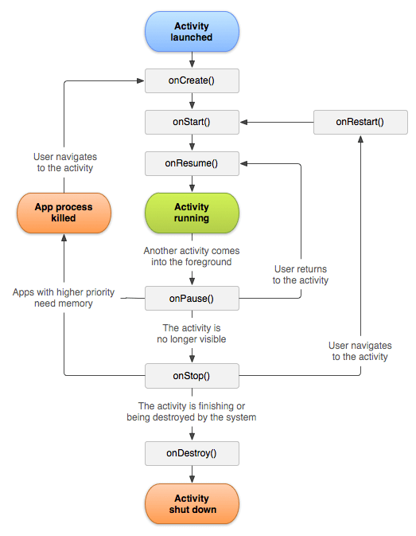

***Figure 1: Application Activity Diagram***

**User Activity Diagram**

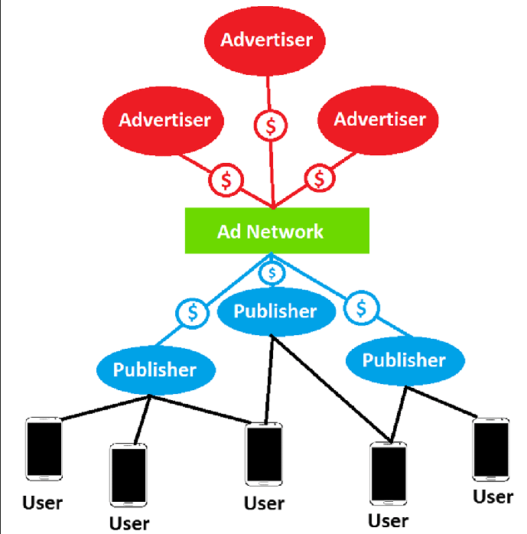

***Figure 2: Application User Activity Diagram***

**Data Flow Diagram**

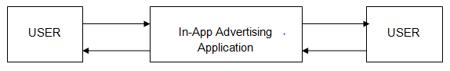 ***Figure 3:*** ***Level 0 Data Flow Diagram***

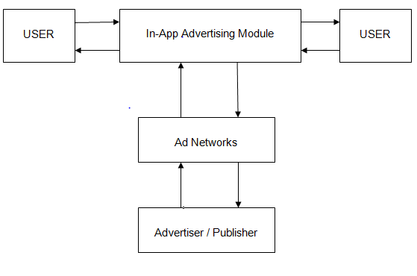 ***Figure 4: Level 1 Data Flow Diagram***

**Class Diagram**

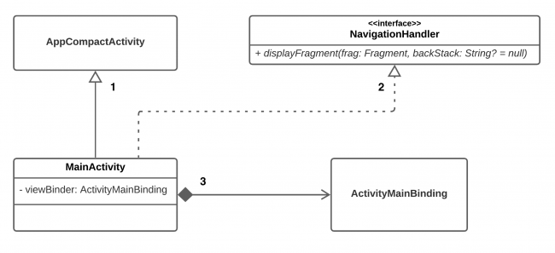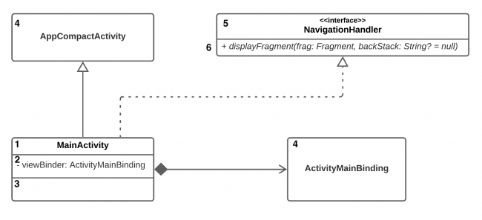

***Figure 5: Class Diagram***

**Use Case Diagram**

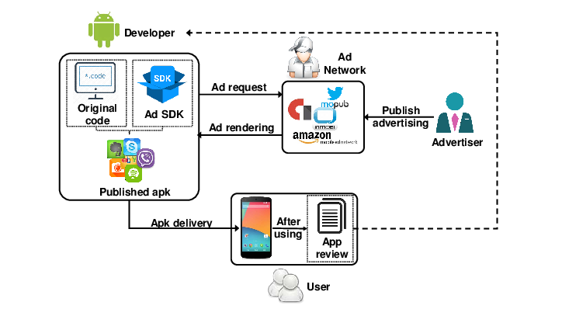

***Figure 6: Use Case Diagram***

**5. Conclusion**

Android In-App Advertising application puts forth the actual working of mobile advertising which creates awareness of brands, products, services, and ideas. Showing different types of ad formats, both application developers and advertisers can earn revenue when user interact with the ads.

**Future Scope**

This project can be enhanced further by adding ad monetization strategies using various types of advertisement formats such as rewarded videos to boost your revenue with quality ads that helps you monetize. The software is flexible enough to be modified and implemented as per future requirements. We have tried our best to present this free and user-friendly android application module for mobile users. We can implement following functionalities to present module:

1. Server notification (Firebase) for android application

2. Application analytics (Firebase) ad revenue calculation, Ads personalization

3. Android application permission

**6. References**

1. <https://developers.is.com/ironsource-mobile/android/android-sdk/>

2. <https://developers.google.com/admob/android/quick-start>/

3. <https://developer.android.com/training/basics/firstapp>